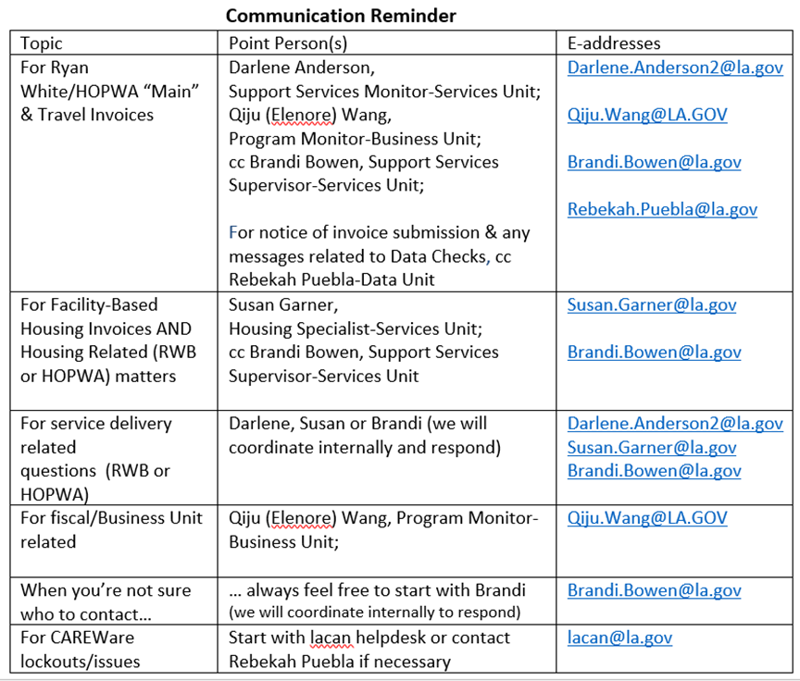
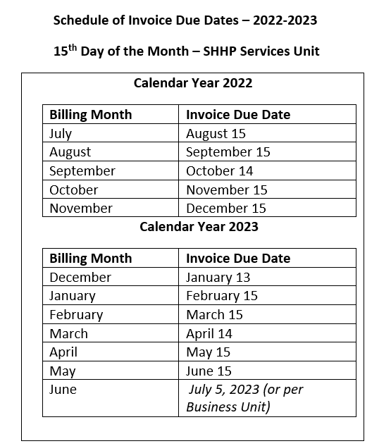

SHHP Service Unit Notes:
- Guidance from SHHP Business Unit supersedes this schedule.
- This schedule is based on contractual expectations which stipulate invoices are due on the 15th of each month.
- If the 15th falls on a weekend, the above moves the due date to the business day prior to the 15th.
- If you have questions or comments, please contact SHHP Services Unit.

